Moldflow® Simulation
- Ultracur3D® RG 3280
User Guideline

DESCRIPTION

QUICK FACTS

Material:
Ultracur3D® RG 3280
Technology:
Digital Light Processing (DLP)
Injection Molding Simulation
Partner:
BASF Ultrasim®
3D printed mold inserts are mainly used in prototype toolmaking but can produce near production quality functional parts of low to medium quantities (approx. 100-1000) as well. Simulation of the injection molding process has become the standard in mold making, used to determine optimum mold filling process parameters and predicting the final shape of the part, minimizing tendencies for shrinking and warpage.

The use of printed mold inserts for the injection molding process requires careful preparation of the inserts to be printed. It also requires focused attention to the individual steps to move seamlessly from design to printing, post-processing and pre-treatment to the actual injection molding process. One essential step is the simulation of the injection molding process.
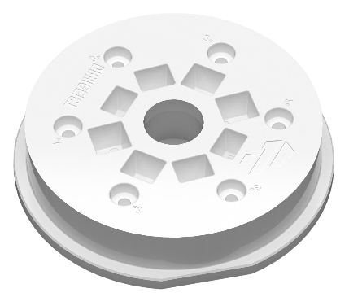
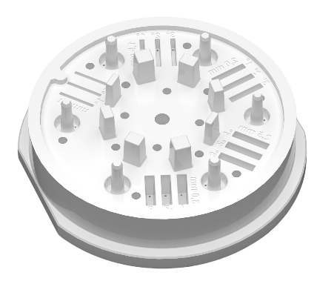
The following is a general guideline on how to set up Moldflow® simulation with Ultracur3D® RG 3280 as the mold material. Further, the “Stonehenge V3 reference design” by SKZ & DREIGEIST was used for verification of simulation with actual trials described in our White paper (Evaluation of DLP 3D Printing for Injection Molding Inserts: A Case Study on BASF Ultracur3D® RG 3280).
“Stonehenge V3 reference design” STL file by SKZ & DREIGEIST

Source: DREIGEIST

MOLD MATERIAL COMPARISON BY CYCLE TIME
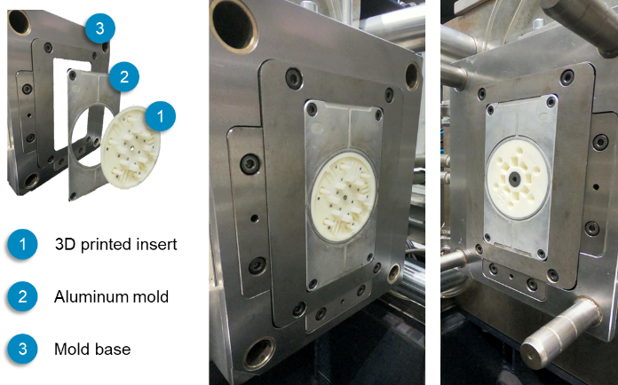
Differences in thermal properties between 3D printed and more conventional metal inserts must be considered. Utilizing Moldflow® simulation helps understanding the impact of these differences on the injection molding process. A guideline for how to set this up is provided at the end of the document.
Mold Material | Conductivity  @200°C  W/(m*C) | Spec. Heat  @200°C  (J/(kg*C)
Ultracur3D® RG 3280 | 0.69 | 1810
Mold-Steel | 29 | 460
Aluminum | 190 | 880

This table shows the required material properties/measurements to simulate the injection molding (IM process with stated mold materials in Moldflow®).

Ultracur3D® RG 3280  44s | All mold elements made out of Tool Steel  31s | All mold elements made out of Aluminium  15s
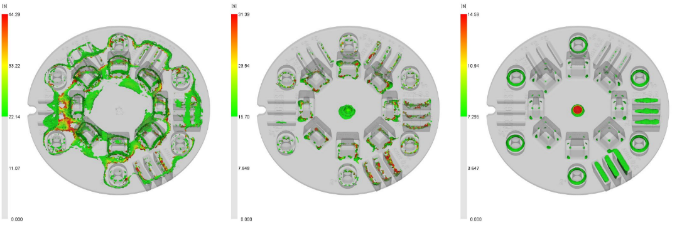
Time to reach ejection temperature is strongly dependent on the mold material heat conductivity. Note the need of a 2-3 times longer cooling time using Ultracur3D® RG 3280 compared to Aluminum.

EXAMPLE PROCESS SIMULATION WITH ULTRACUR3D® MOLDS
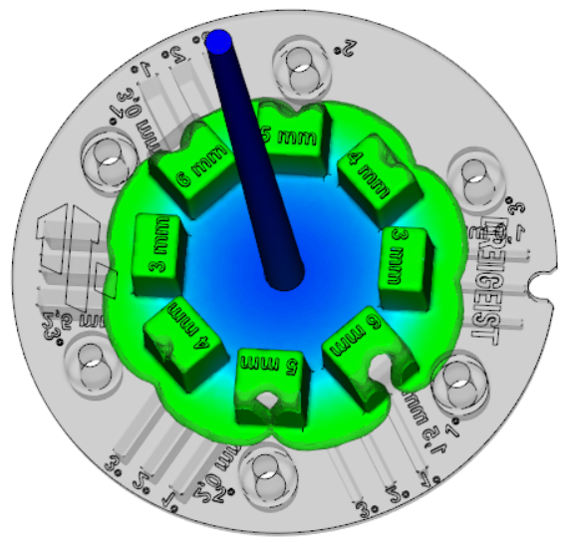
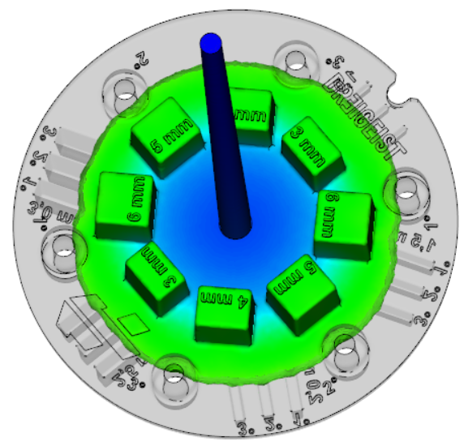
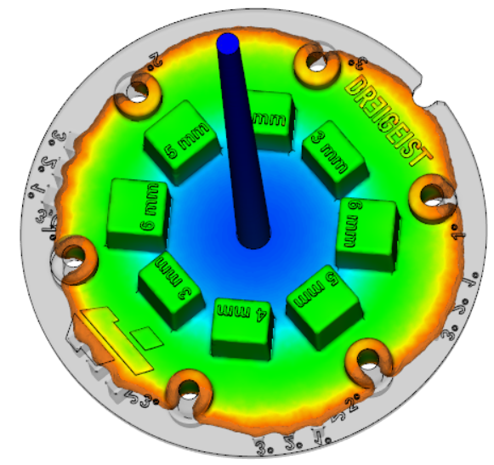
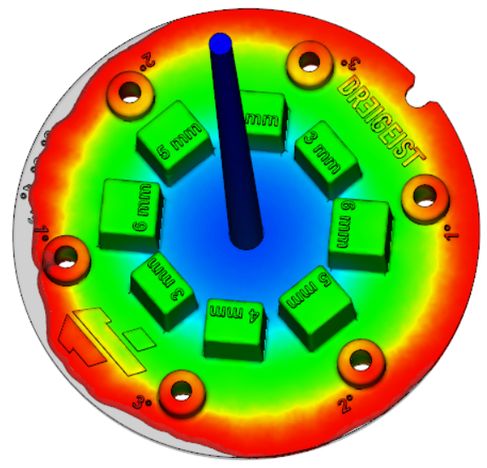
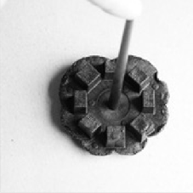
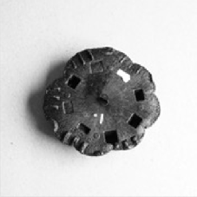
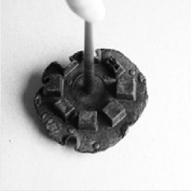
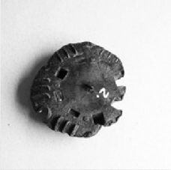
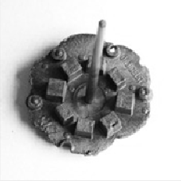
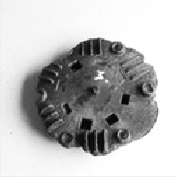
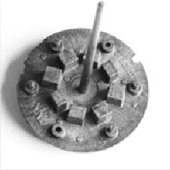
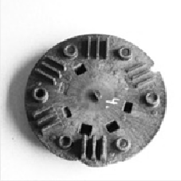
For injection molding it is recommended to start with a mold filling study. This also helps to bring the mold into thermal balance before full loading forces are applied. It is advisable to start with lower forces such as closing and locking forces, injection pressure, etc.
50% filling 60% filling 85% filling 98% filling
Required cooling time can be estimated in process simulation. Process simulation can also provide further input on the shear rate while filling the mold and the expected shrinkage and warpage of the part, as shown below.
We can support your project with years of simulation experience in injection molding. If you have any questions or would like more information, contact: sales@basf-3dps.com.
Starting with 70% filling of the mold

Source: DREIGEIST

MOLDFLOW® SIMULATION SETUP
Meshing
Load
RG 3280 Material Card
(link)
Start
Simulation
- Mesh parts using 3D mesh. Each image shows separate views taken during the injection molding process.

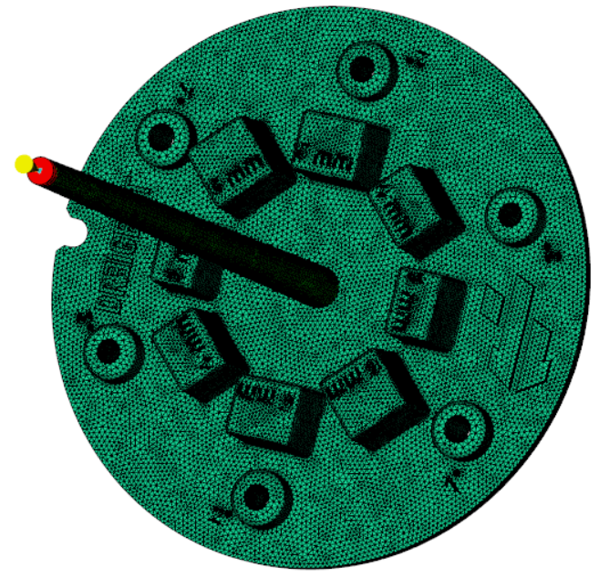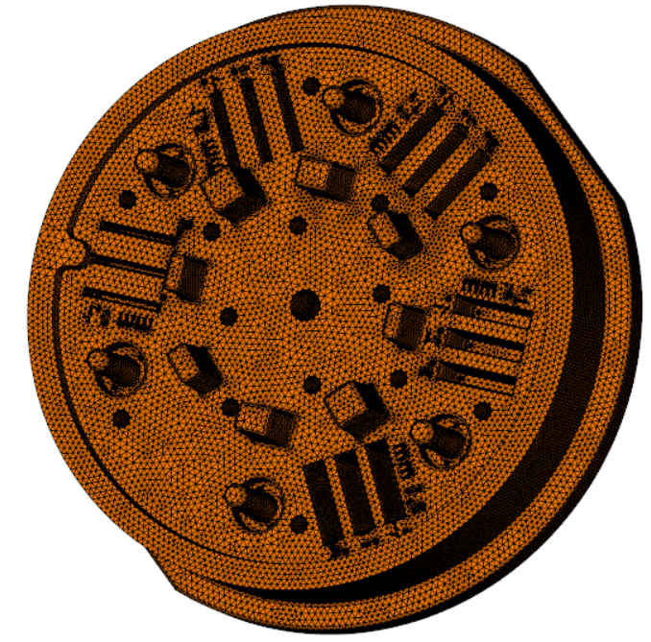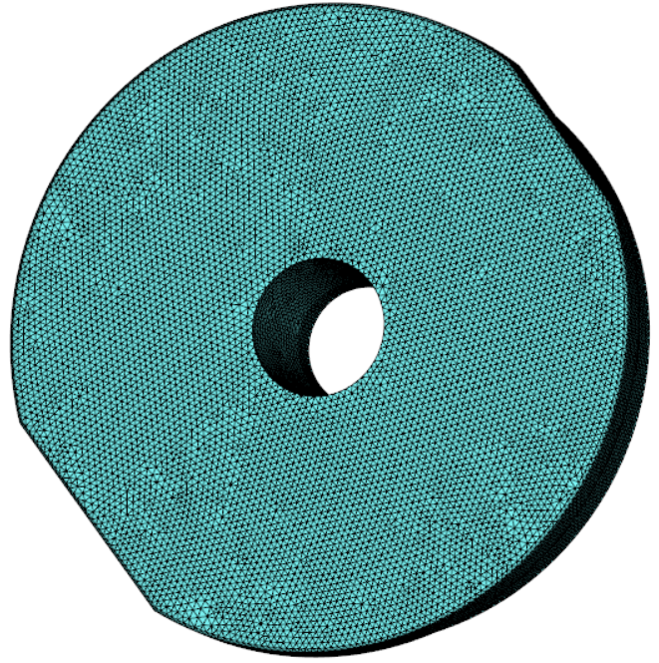
Molded part 3D printed ejector side 3D printed nozzle side

- Assign properties and materials for the 3D-printed inserts halves (in separate views).

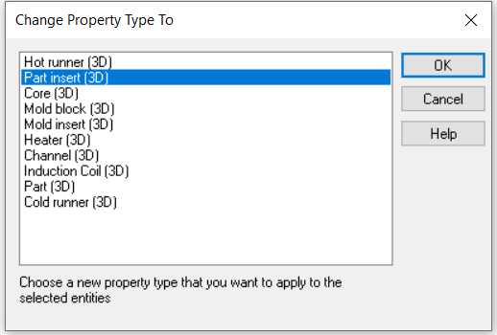
2.1 Define 3D printed inserts as “Part insert (3D)”

2.2 Assign material properties using the material file:
Ultracur3D_RG3280.20020.udb

2.3 Set the initial temperature equal to mold surface
temperature in process settings

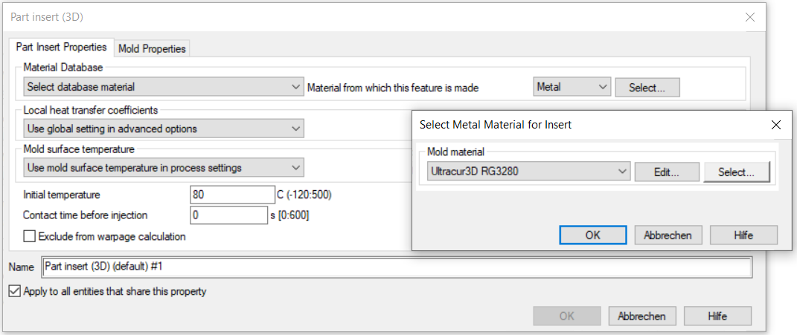

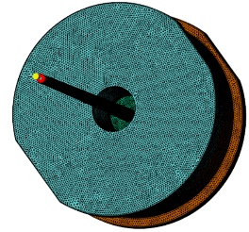
Add
Add
- Combine the images: add reports with 3D printed inserts to the molded part study using the „Add“ function.

- Complete the setup
4.2 Choose the right material surrounding the 3D printed mold insert
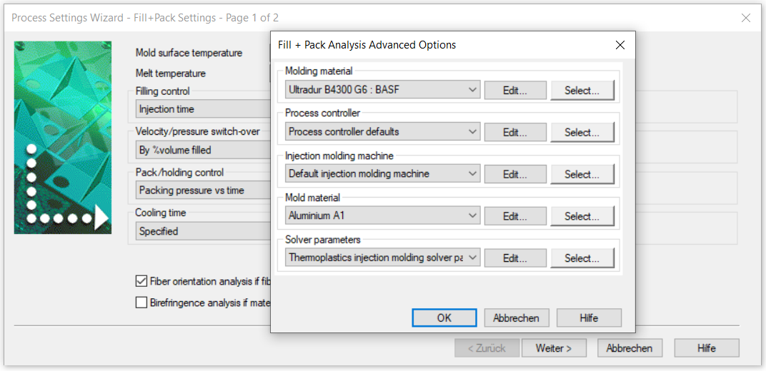
4.1 Cooling time should be 2-3 times longer than for conventional tool materials

