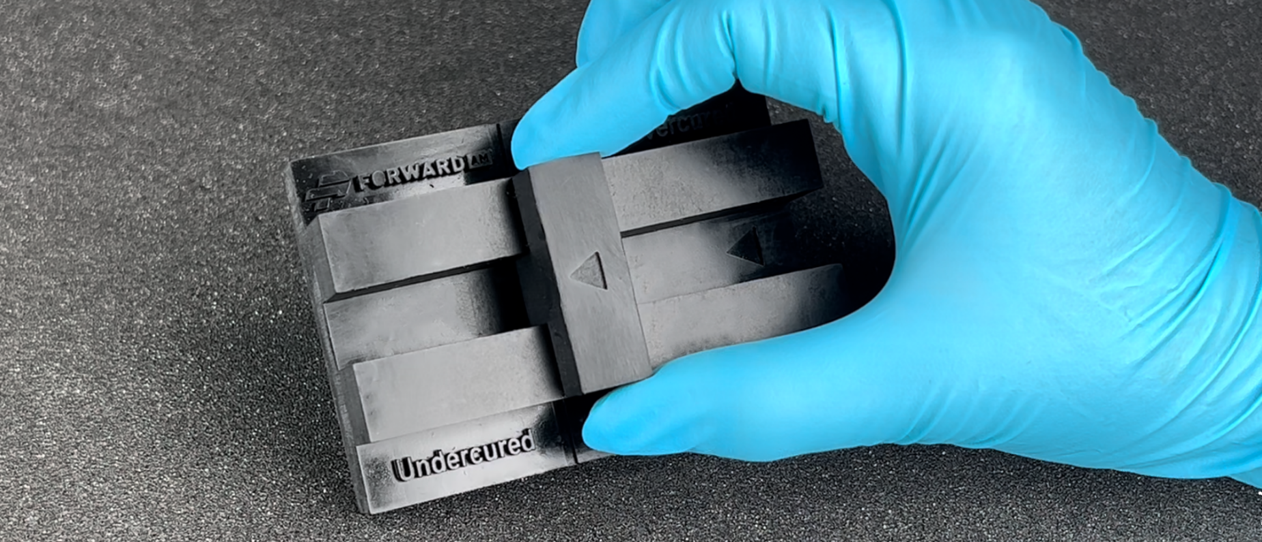

Parameter
Optimization
User Guideline

OVERVIEW

These proceedings are general guidelines to optimize the layer exposure time for every BASF resin.
The layer exposure time is a determinant factor for getting good prints. Using an incorrect one will result in losing precision on the model.

RIGID / TOUGH

The calibration test is made up of two parts: a larger part with a central rail (1) and a smaller part (2).

PRINTING & PROCESSING
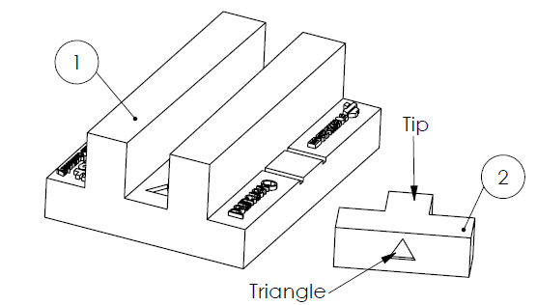
- It is important to prepare the scene in such a way that part 1 (the rails) and part 2 (the tip) are positioned up-wards (i.e., the triangle touching the platform), as shown in the image on the right. This will avoid that the bottom exposure time affect the interpretation of the results.
- The starting parameters should be taken from the user guideline of the respective Ultracur3D® resin. If you do not have the user guideline, please ask your supplier.
- Please do not rescale the part as it might have an influence on the result.
- After printing, follow the cleaning and post curing process of the parts according to the user guideline of the material.

OPERATION

- Place the movable part (2) on the rail (1). The tip of the part must be inside the rail. It must be positioned so that the triangles on both of the parts are in the same direction.
- Gently slide part 2 until it can no longer advance. The part should be not forced to move further.

ANALYZING THE RESULTS

Depending on the position of part 2 it can be determined whether the exposure time used is correct:
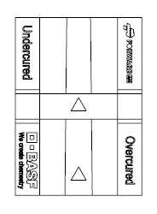
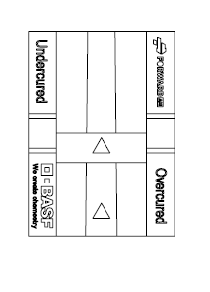
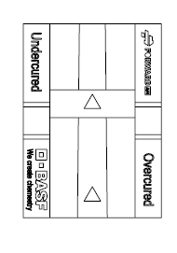
*
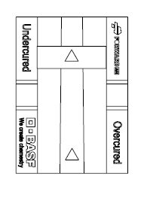
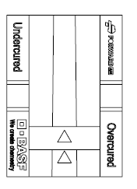

Correct result
The perfect exposure time is when part 2 stops between the lines.
*The curing time is also correct when the part 2 touches any of the two lines.
Incorrect result
If part 2 is in the red zone: the part is overcured. The exposure time is too long, it is necessary to reduce it.

Incorrect result
If part 2 is in the red zone: the part is undercured. The exposure time too low, it is necessary to increase it.

FLEXIBLE

The calibration test is made up of two parts: a larger striped cone (3) and a ring (4).

PRINTING & PROCESSING
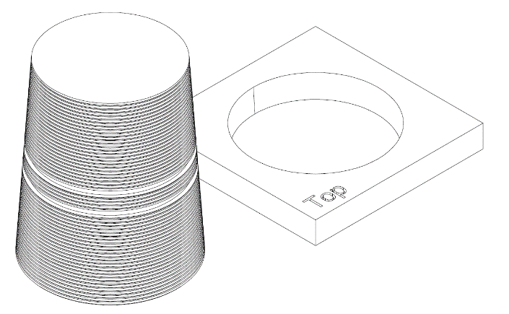
- It is important to prepare the scene in such a way that part 3 (the cone) and part 4 (the ring) are positioned up-wards, as shown in the image on the right. This will avoid that the bottom exposure time affect the interpretation of the results.
- The starting parameters should be taken from the user guideline of the respective Ultracur3D® resin. If you do not have the user guideline, please ask your supplier.
Cone
Ring
- Please do not rescale the part as it might have an influence on the result.
- After printing, follow the cleaning and post curing process of the parts according to the user guideline of the material.

OPERATION

- Place the ring (2) on the cone (1). The ring has a face where “Top” is written. Place the ring on the cone so that the top letters face upwards.
- Gently move the ring down the cone until it can no longer advance. The part should be not forced to slide down further. The lines will help to try to make the ring as flat as possible.

ANALYZING THE RESULTS

Depending on the position of ring it can be determined whether the exposure time used is correct:
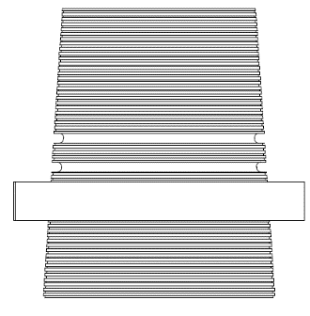
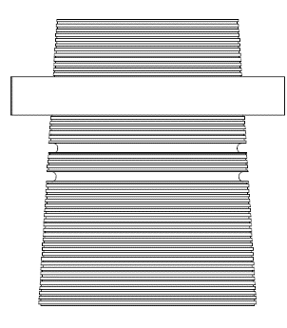
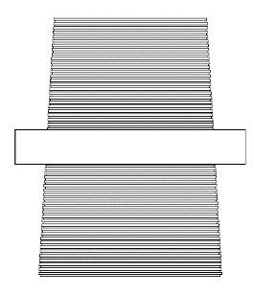
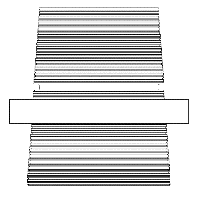
*

Correct result
The perfect exposure time is when the ring stops between the lines.
*The curing time is also correct when the ring touches any of the two lines.

Incorrect result
If the ring is in the red zone: the part is overcured. The exposure time is too long, it is necessary to reduce it.

Incorrect result
If the ring is in the red zone: the part is undercured. The exposure time too low, it is necessary to increase it.

It is also seen that in case of undercuring, the cone does not print fully or at all. This is also an indication to increase the exposure time.

